Practical no. 18
Name :- Danish Altaf Solkar Enrolment no. :-24111590805
Class :- CO3K – B Subject :- OOP
Aim :- Write a C++ programs to interchange the values of two int, float and char using function overloading.
Program :-
#include<iostream.h>
#include<conio.h>
void swap(int a,int b){
int temp;
cout<<"\nBefore swapping :- ";
cout<<"\n"<<a<<"\n"<<b;
temp=a;
a=b;
b=temp;
cout<<"\nAfter swapping :- ";
cout<<"\n"<<a<<"\n"<<b;
}
void swap(float a,float b){
float temp;
cout<<"\nBefore swapping :- ";
cout<<"\n"<<a<<"\n"<<b;
temp=a;
a=b;
b=temp;
cout<<"\nAfter swapping :- ";
cout<<"\n"<<a<<"\n"<<b;
}
void swap(char a,char b){
char temp;
cout<<"\nBefore swapping :- ";
cout<<"\n"<<a<<"\n"<<b;
temp=a;
a=b;
b=temp;
cout<<"\nAfter swapping :- ";
cout<<"\n"<<a<<"\n"<<b;
}
void main(){
clrscr();
swap(10, 20);
swap(1.2f, 3.4f);
swap('x', 'y');
getch();
}
Output :-
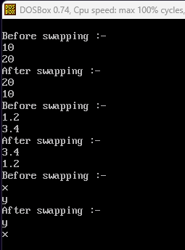

Aim :- Write a C++ programs that find the sum of two int and double number using function overloading.
Program :-
#include<iostream.h>
#include<conio.h>
void sum(int a,int b){
int result;
cout<<"\nValue of a :- "<<a;
cout<<"\nValue of b :- "<<b;
result=a+b;
cout<<"\nSum of integers :- "<<result;
}
void sum(double x,double y){
double result;
cout<<"\nValue of x :- "<<x;
cout<<"\nValue of y :- "<<y;
result=x+y;
cout<<"\nSum of doubles :- "<<result;
}
void main(){
clrscr();
sum(10,20);
sum(1.2345,6.7890);
getch();
}
Output :-
